**Marketing Channel Attribution (MarCAt): Tool Kit**

**Input file:**

**Type:** *.csv* or *.xlsx*

**Location:** “\MarketingChannelAttribution\data_files\”

**Should contain** following features in the data file.

|  |  |
| --- | --- |
| Feature | Description |
| visitor_id​ | Identification of the visitor​ |
| visit_time​ | Timestamp of a visit​ |
| Interaction​ | Type of interactions (Impression/ conversion)​ |
| is_converted​ | Binary (1: conversion and 0: no conversion)​ |
| Channel_name​ | Touch point which lead to an action (soft/hard)​ |

**Sample Input:**

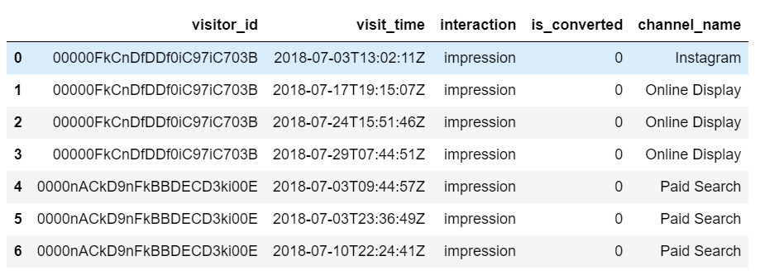

**Usage:**

* Place the data file in specified location
* Make sure column headings are as mentioned in the **input feature list**
* Create an environment using either the ***requirements.txt*** or ***conda_requirements.yml*** file
* Execute the ***channel_attributionui.py***